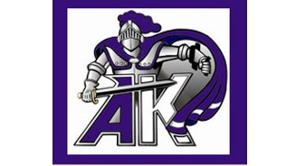
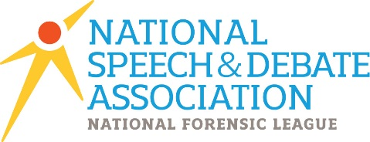
Ardrey Kell High School
Speech and Debate

Materials

- Students will need one notebook or folder to store notes, handouts, readings, and other classroom materials – whichever you prefer as long as it allows you to organize materials!
- Pens and/or pencils
- Highlighters
- Index Cards (3” x 5”)

Grading

Students will be assessed in various manners throughout the year, individually and as an active member of a group. Students should expect to earn credit on a daily basis for participation and assignments.

Formal (scripts, performances, debates) 70%
Informal (homework, class work) 30%

Students in the Speech and Debate course will have the opportunity to take skills learned in the classroom and apply them to inter-school competition on the Speech and Debate team if they choose but the two are not related. Students will not be rewarded or penalized for participation or lack thereof (though we’d love to have you!)

Tutoring

By appointment, tutoring will be offered by Mr. Harrow. Priority will be given to those who have difficulty applying concepts studied in class. Advance notice must be given of a desired tutoring session to ensure the highest quality of individual instruction.

Rules and Expectations

Our classroom will be governed using the policies outlined in the Student’s Rights and Responsibilities Handbook and the standards procedures specific created for Ardrey Kell High School.

Syllabus

Unit I Fundamentals of Public Speaking
Unit II Informational Speaking
Unit III Fundamentals of Debate
Unit IV Creative Oral Expression
Unit V Student Legislative Debate
Unit VI Original Persuasive Advocacy
Unit VII Public Advocacy Project

Throughout the year, should you have questions or concerns please feel free to contact me by email!

Sincerely,

Chris Harrow
christopherc.harrow@cms.k12.nc.us

