Speech and Debate – Final Project
So You Want To Be A Senator…
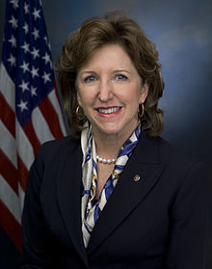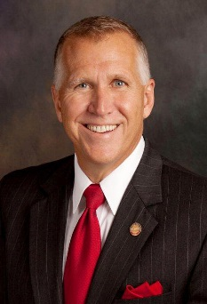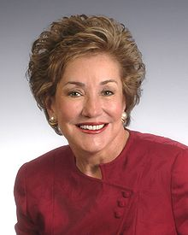

For your final project you will assume the role of a candidate running to be the next Senator from the state of North Carolina. It is your job to effectively inform, argue, and persuade on issues that matter to your state and your country in order to earn the votes of the people.
To achieve this, you will have to meet several objectives – similar to what a real-life candidate must accomplish – in order to get your campaign off the ground.

Objective #1 – Statement of Candidacy (10 pts)
Purpose
To earn votes, people must believe you have strong reasons for running. In this objective you will identify those reasons
Directions

In 250 words you must introduce yourself as a candidate. This statement must…
- Include a brief introduction about yourself
- Identify one local NC issue that you believe is important
- Why you care about it
- What you hope to do about it
- Identify one national US issue that you believe is important
- Why you care about it
- What you hope to do about it
- A strong concluding line
Objective #2 – National Issue Bill (40 pts)
Purpose
To show that you will be ready to act in Washington, you must draft a bill on the national issue that you identified in your candidacy, and be prepared to support that bill
Directions

First, you must use the Bill Template on the website to draft a bill that takes action on the same national issue you identified in your statement from Objective 1.
Second, in 300-400 words you must write an Affirmative argument that you would present to the US Senate in support of your bill. This argument must include…
- At least one claim
- At least one warrant supported by cited evidence from a reputable news source
- At least one impact
Objective #3 – Local Issue Speech (30 pts)
Purpose
To convince the people of NC that you care about them, you’ll need to persuade them on the local issue you identified in your candidacy
Directions

In 400-500 words you must write a short speech that you would deliver at a campaign stop (think a local event where candidates speak directly to voters and the media, like when Presidential candidates hold rallies and give speeches while on campaign)
The speech must include…
- A problem statement that addresses the local NC issue you identified in Objective 1
- At least one example or explanation supported by cited evidence from a reputable news source that shows how this issue affects the people of NC
- At least one solution to the issue that you plan to achieve if elected
Objective #4 – TV Spot (20 pts)
Purpose
Your campaign has purchased a 90 second primetime TV spot to air before the election. You must use it to convince voters to support you
Directions

In a 90 second recorded clip you must present a statement that is designed to sway voters to support you. This statement must…
- Identify a deficiency or problem with the current government
- Explain how you will change or fix that deficiency/problem if elected
In addition, remember that PEOPLE CAN SEE YOU AND HEAR YOU and you must present yourself effectively. With that mind, in your TV spot you should…
- Maintain eye contact with the camera
- Employ effective facial expressions, body posturing, and physical gestures
- Use strong inflection and effective pacing
For this TV spot you may go as BIG as you want. Dressing up, including passionate and patriotic rhetoric, even using visuals or music are things you may do to help increase your appeal (though none are required). The sky (and 90 seconds) is the limit!

Submission Instructions
- Create a new folder in your CMS Google Drive. Title the folder [Last Name, First Name] Final Project ex: Harrow, Chris Final Project
- Share that folder directly with Mr. Harrow christopherc.harrow@cms.k12.nc.us
- When each objective is complete you must upload the final copies into this folder. Use a separate document for each objective. Title each document with the objective number ex: your 250 word candidacy statement will be in a document titled “Objective 1”
You should end up with five (5) items: Obj. 1, Obj. 2A (the bill), Obj. 2B (the argument), Obj. 3, and a video clip for Obj. 4
Due Dates
1st Block: June 5 2nd Block: June 6 3rd Block: June 7 4th Block: June 8 Late: June 9
Any work not completed and uploaded into your folder by 7:25 AM on the due date is late and will incur a 20% penalty each day that it is late. Any work not completed and uploaded by 12:00 PM (noon) on June 9 will not be counted.

